Switch bringup and Code flow for Vlan config
Download SONIC-VS Image:
Get a pre-built docker-sonic-vs.gz image. The easiest source is sonic.software (community mirror); the official fallback is the SONiC Azure pipeline, where you pick a branch (e.g. 202405) under the 'vs' platform, open the latest successful build's artifacts, and download target/docker-sonic-vs.gz.
Load and run the SONiC-VS container
Load the image with `docker load < docker-sonic-vs.gz`, then create a fake switch network namespace with the buildimage helper script, and start the switch itself: `docker run --privileged --name vs -d docker-sonic-vs`. The `--privileged` flag is required because SONiC's containers manage networking and kernel resources directly.

Get a shell inside the running switch with `docker exec -it vs bash`. Sample command output inside bash shell
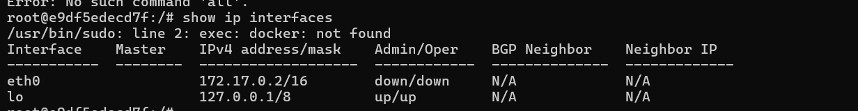
Configure Vlan
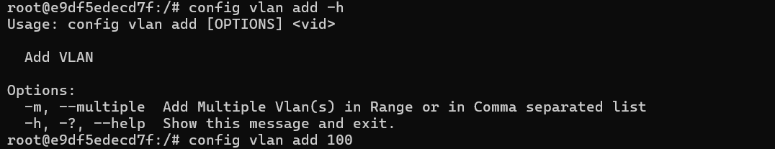
Below shows the Interface created in Linux for Vlan100
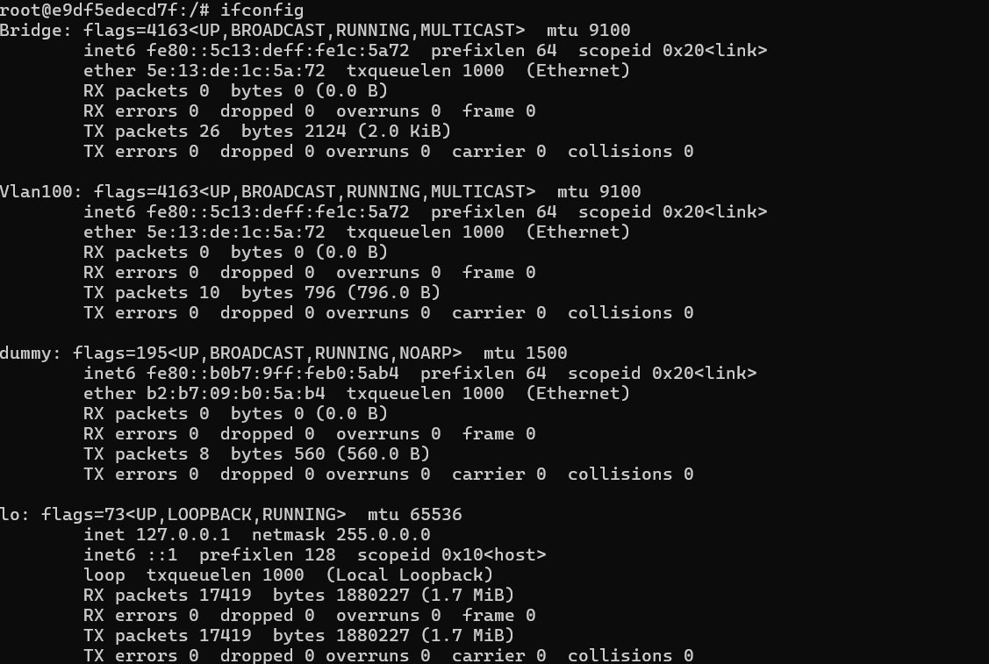
Vlan100 Entry present in CONFIG_DB
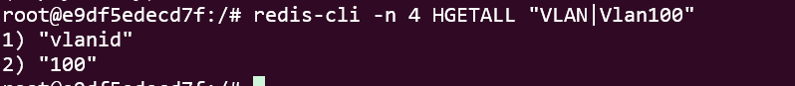
Vlan100 Entry present in APPL_DB
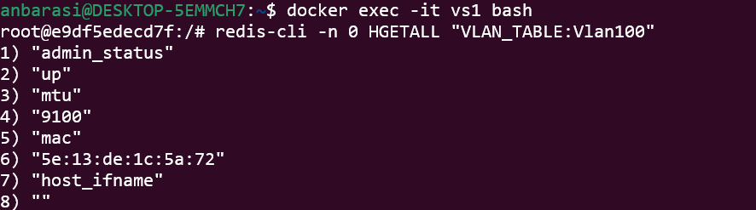
Vlan100 Entry present in ASIC_DB

Command to debug the flow
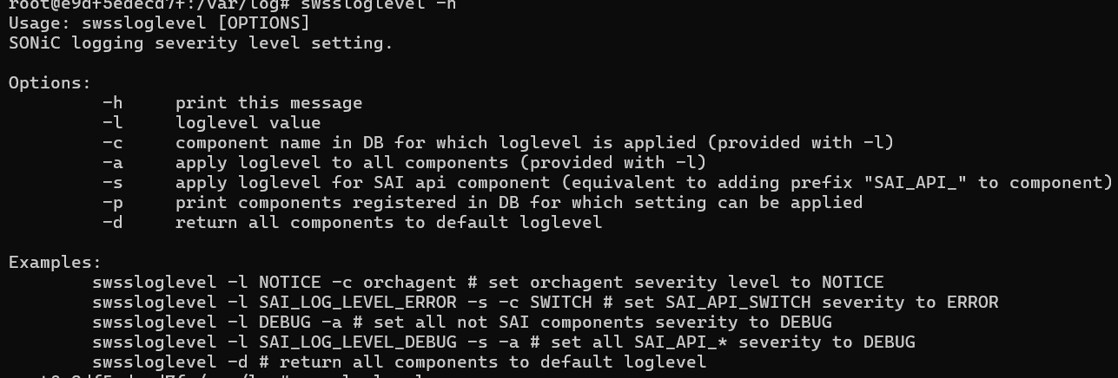
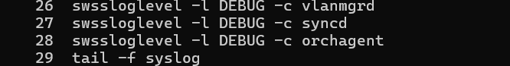

Syslog sample file for vlan200 config

